**EOG-integrated eyeglasses**

1. **Brief description of the project (max. 100 words):**

The project focuses on the development of eyeglasses integrated with Electrooculography (EOG) sensors. EOG sensors track eye movements by measuring the electrical potential difference around the eyes. This technology is especially helpful for improving human-computer interaction and for developing assistive devices for those with mobility or communication difficulties.

1. **List of project objectives:**

* Develop a functional prototype of EOG-integrated eyeglasses.
* Optimize electrode placement for accurate signal detection.
* Implement robust signal processing techniques to acquire and process data in real-time, enabling efficient, effective, and accurate tracking and categorization of various eye movements.
* Ensure user comfort and ease of use in the final design.

1. **Summary of the relevant academic/industrial/commercial literature reviewed:**

The literature review delved into optimal electrode placements surrounding the eyes to ensure precise capture of EOG signals. Various signal processing methods, including median and low-pass filtering, notch filters were examined to reduce artifacts such as external noise and EMGs, which are essential for improving signal clarity. We also studied application of Fourier transform in identifying dominant frequencies and differentiating between noise and signals of our interest. Research demonstrates the usefulness of wavelet transformations and Fourier analysis in real-time data processing, which is essential for precise classification of eye movements. Future developments in EOG technology will concentrate on wireless systems and machine learning and Neural networks (CNN or ANN) integration. Beyond simple detection, the technology is potent to extended to and enhance assistive devices and human-computer interaction. These advancements are meant to push the technology in the direction of more advanced features and more useful applications in interactive technologies and especially healthcare.

1. **Current status of the project:**

* Design Finalization: Completed CAD design of the main frame.
* Coding: Implemented pre-processing and processing code for EOG signals.
* Data Collection: Collected data for blink detection and lateral eye movements using EXG PILL in the lab.
* Algorithm Development: Developed a blink detection algorithm and stored timestamps in a CSV file.
* Biomedical Signal Processing: Studied various steps involved in pre-processing, filtering, and processing biomedical signals, including Fourier analysis.

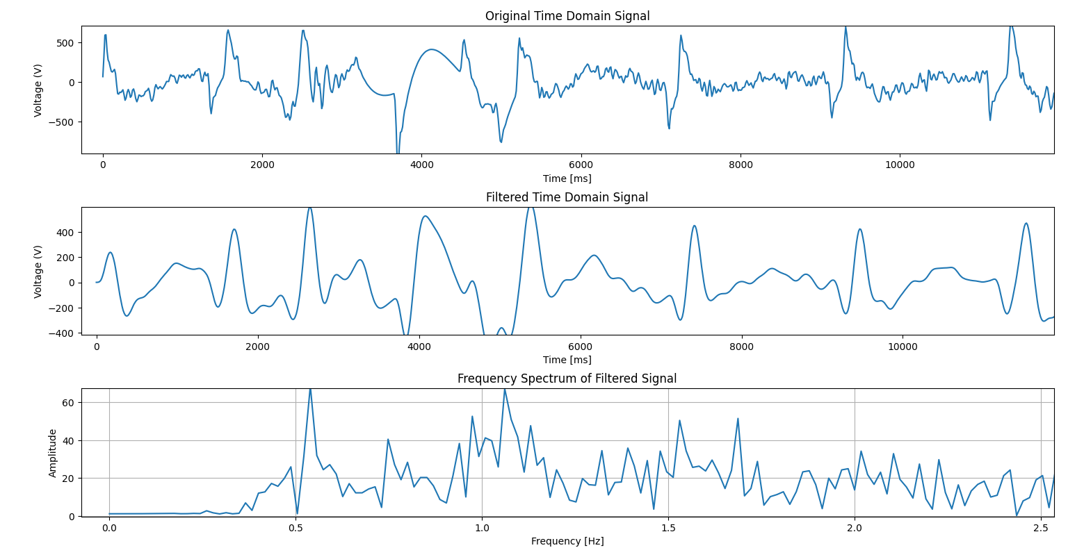

1. **Difficulties faced during this period:**

* Noisy Signals: Movement of electrodes and loss of contact caused noisy signals.
* Artifact Noise: High-frequency noise from EMG and other artifacts interfered with EOG signals.
* Electrode Stability: Issues with signal stability using certain electrode placements.
* Electrode Placement: Need for firm electrode placement near the eyes. Solution: Considering spring mechanisms to ensure stable placement.

1. **List of hardware components used in the project (e.g. microcontroller, motors etc.) until now:**

* Arduino board
* Ag/AgCl electrodes
* EXG Pill

1. **List of software used in the project until now:**

* SolidWorks
* Arduino IDE
* Virtual Studio Code

1. **Frequency/number and details of meetings with the faculty involved:**

Initial 3 meetings were about literature review and discussion of theory of biomedical signal processing. He also briefed us about the expected design of the eyeglasses. We started working on collecting data after the 4th meeting.

1. **Plan for the next phase:**

* Try to improve the circuit to get higher accuracy.
* Improve signal processing methods to acquire a clean and useful signal.
* Develop classification methods for different eye movements in real-time.
* Begin prototyping and acquire necessary materials such as electrodes.
* Conduct further testing and optimization of the eyeglasses design.
* Make the first prototype to understand and enhance electrode placement and the spring mechanism.

1. **Photos of the team while working on the project:**

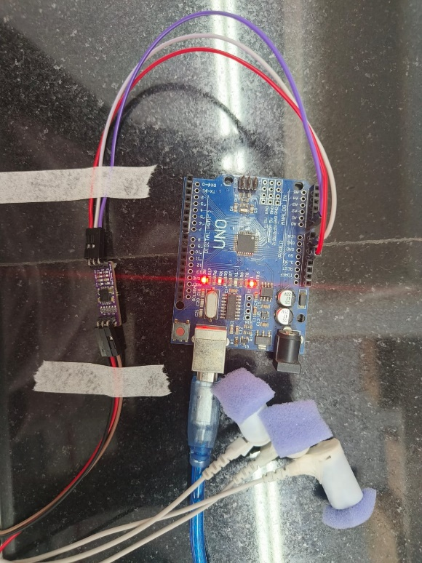

Setup of EXG Pill in Prof. Ambarish’s Lab.

***References:***

1. **Design of Low cost Data Acquisition Circuit with Feature Extraction**

Three electrode placement and signal processing.

<https://www.researchgate.net/publication/350869406_Design_of_Low_cost_Data_Acquisition_Circuit_with_Feature_Extraction>

1. **Classifying Electrooculogram to Detect Directional Eye Movements**

Filtering math given and classification of different EOGs

<https://www.researchgate.net/publication/259525930_Classifying_Electrooculogram_to_Detect_Directional_Eye_Movements>

1. **Electrooculography: technical standards and applications. The International Federation of Clinical Neurophysiology**

Good explanation on signal processing

<https://pubmed.ncbi.nlm.nih.gov/10590990/>

1. **Analysis of Electrooculography signals for the Interface and Control of Appliances**

<https://www.researchgate.net/publication/282866990_Analysis_of_Electrooculography_signals_for_the_Interface_and_Control_of_Appliances>